**AI-based Generative QA System**

**Group 19**

Guide: - **Prof. Manish Srivastav**  
Mentor: - **Prateek**Team Members: - **Bhagyalakshmi K, Nishant C, Balaji D, Kethavardhan K, Bharavi B**

**1. Email Subject Line Generation 3**

1.1 Abstract 3

1.2 Introduction 3

1.3 Problem Statement 4

1.4 Literature Study 4

1.5 Models Comparison 4

1.6 Methodology 5

1.6.1 Data Retrieval: 5

1.6.2 Dataset Partitioning: 5

1.7 Experimentation 6

1.7.1 Installation of Essential Libraries: 6

1.7.2 Model Selection: 6

1.7.3 Hyperparameter Optimization: 7

1.8 Result and Analysis 8

1.8.1 Results 8

1.8.2 Deployment: 9

1.9 FUTURE SCOPE 11

1.10 Real World Application 11

1.11 CONCLUSION 12

**2. AI Question Answer Generation 13**

2.1 Abstract 13

2.2 Introduction 14

2.3 Problem Statement 14

2.4 Literature Study 14

2. 5 Methodology 15

2.5.1 Data Retrieval: 15

2.6 Experimentation 16

2.6.1 Installing Required Libraries: 16

2.6.2 Model Selection: 16

2.6.3 Hyperparameter Optimization: 17

2.7 Result and Analysis 18

2.7.1 Results 18

2.7.2 Deployment: 18

2. 8 FUTURE SCOPE 19

2.9 Real World Application 20

2.10 CONCLUSION 21

# Email Subject Line Generation

## 1.1 Abstract

This project is to enhance advanced AI models, particularly the Generative Pre-trained Transformer (GPT), this project aims to automate the generation of concise and impactful email subject lines. The primary goal is to train these AI models to understand the nuances of email content and context, enabling them to produce subject lines that succinctly capture the essence of the message. Through the utilization of AI technology, this endeavor seeks to transform email communication by providing users with a robust tool that not only simplifies the process but also improves the overall effectiveness and engagement of digital correspondence.

## 

## 1.2 Introduction

The initial phase of this project centers on fine-tuning a GPT (Generative Pre-trained Transformer) model to generate succinct email subject lines tailored to the content of the email body. This task entails training the model to grasp the context and substance of emails, enabling it to produce concise and impactful subject lines that encapsulate the message's essence. The overarching objective is to enhance the email communication process by automatically recommending relevant subject lines, thereby improving user experience and engagement.

The motivation behind undertaking the Email Subject Line Generator project stems from the significant role emails play in our digital routines. The crux of the matter lies in the fact that the subject line serves as the initial point of engagement for recipients, akin to a book cover. A compelling subject line prompts recipients to open the email, while a lackluster or ambiguous one may lead to dismissal. Given the deluge of emails received daily, crafting effective subject lines for each one can pose a daunting and time-intensive challenge.

Thus, the driving force behind this project is to simplify our email experiences. Leveraging advanced computational techniques, our aim is to automatically generate enticing subject lines that pique recipients' interest and prompt them to engage with our emails. By adopting such technology, we not only streamline our own time management but also enhance communication effectiveness in both personal and professional spheres. Ultimately, the objective is to make email communication more efficient and impactful.

## 1.3 Problem Statement

The challenge at hand entails distilling a concise email subject line from a provided text input, usually the content of an email body. The objective is to generate a succinct textual summary that accurately encapsulates the primary content and intent of the email. The resulting subject line must be succinct and coherent, comprising only a restricted number of words.

## 1.4 Literature Study

The literature review presented here concentrates on the task of "Email Subject Line Generation."

"This Email Could Save Your Life: Introducing the Task of Email Subject Line Generation" (ACL 2019) serves as a pivotal contribution, inaugurating the Email Subject Line Generation task by elucidating the intricacies and goals involved in crafting concise and pertinent subject lines for emails. It establishes the groundwork for further exploration and investigation in this domain.

"Generating Email Subject Lines with Human Touch: A Review of Methods and Datasets" (2019) offers a comprehensive examination of the methodologies and datasets employed in tasks related to email subject line generation. It sheds light on various strategies and hurdles encountered within this field of study.

In "Extractive Summarization of Emails Using Text Rank" (ACL 2019), the utilization of extractive summarization methods, particularly Text Rank, is examined in the context of generating email subject lines. The paper delves into the implementation of graph-based techniques to pinpoint pivotal sentences within emails.

"Email Subject Line Generation: A Survey" (2021) offers a comprehensive exploration of diverse methodologies and strategies employed in the generation of email subject lines. Encompassing traditional methodologies alongside recent advancements, this survey paper provides a detailed analysis of the field's evolution.

## 1.5 Models Comparison

|  |  |  |
| --- | --- | --- |
| **Criteria** | **BART (Bidirectional and Auto-Regressive Transformers)** | **GPT (Generative Pre-trained Transformer)** |
| **Model Type** | Seq2Seq (Encoder-Decoder Transformer) | Autoregressive Transformer-based Generator |
| **Model Size** | Varies (~400M to 1.5B parameters for BART-large) | Varies (GPT-3 has 175 billion parameters) |
| **Architecture** | Encoder-Decoder (similar to T5) | Decoder-only (autoregressive) |
| **Compression** | Can be compressed with pruning, quantization, and distillation | Supports pruning, quantization, and distillation |
| **Performance** | Strong in summarization, translation, and text generation tasks | State-of-the-art in text generation, dialogue systems, completion, etc. |
| **Latency** | Lower latency compared to T5 due to more efficient autoregressive decoding | Lower latency due to autoregressive generation, but dependent on size |
| **Memory Usage** | Lower than T5 but higher than BERT | Typically lower than T5 for similarly sized models |
| **Use Cases** | Summarization, text generation, translation, question answering | Text generation, completion, dialogue systems, question answering |
| **Fine-Tuning** | Fine-tuned for text generation tasks like summarization, translation | Fine-tuned for text generation and NLP tasks |

## 1.6 Methodology

In tackling the email subject line generation task, we embraced a sequence-to-sequence modelling methodology. Our focus was on leveraging variants of the Transformer architecture, including **BART(Bidirectional and Auto-Regressive Transformers)** and **GPT-2**  models, renowned for their proficiency in generating coherent and contextually pertinent text sequences.

### 1.6.1 Data Retrieval:

* Our initial phase focused on acquiring essential data, facilitated by the TS Team through GitHub. This dataset, known as the Annotated Enron Subject Line Corpus (AESLC), comprises three folders labeled "train," "dev," and "test." Within each folder are text files containing email bodies and their corresponding annotated subject lines, categorized under prompts such as "email," "subject," "ann0," "ann1," and "ann2."

### 1.6.2 Dataset Partitioning:

Next, the dataset underwent partitioning into three separate categories: email bodies, subjects, and annotations. This division facilitated the creation of distinct training and validation datasets. Generally, the email bodies were designated as the source text, whereas the annotated subjects were employed as target sequences for model training purposes.

We developed a script to extract data from the provided dataset, resulting in the creation of three distinct text files: train.csv, test.csv, and dev.csv. Each consists of the input_text(mail body) and target_text(subject line). This script was designed to format the data with a specific prompt structure. Each entry within the text files follows a format that includes the email body and annotated subjects. The prompt structure consists of 'Generate subject for the below email: ' followed by the email body text, truncated to the first 1000 words, and new line characters' separating different sections and the “Subject: “ line with actual subject line at the end.

## **1.7 Experimentation**

### 

### 1.7.1 Installation of Essential Libraries:

In order to support the model's development and training process, critical libraries and packages were installed. These encompassed various libraries such as Transformers, Evaluate, Torch, and NumPy, alongside packages essential for computing evaluation metrics like ROUGE Score and SacreBLEU. Furthermore, integration of components such as the BART and GPT-2 tokenizers and Trainers was executed to enhance the functionality of the system.

### 1.7.2 Model Selection:

The decision was made to utilize a BERT/GPT-2 variant as the foundational model for text generation purposes. BERT/GPT-2 models have showcased robust performance across a spectrum of Natural Language Processing (NLP) tasks, rendering them well-suited for tasks such as text summarization and, notably, email subject line generation.

1. Loss Metric Computation for Training and Validation:
2. Throughout the training phase, loss metrics were computed to gauge the disparity between the model-generated email subjects and the target annotated subjects. These metrics served to quantify the degree of dissimilarity and were not only assessed during the training process but also on the validation dataset following each training epoch to track the model's advancement. To compute both training and validation losses, a range of evaluation metrics including "Bleu" and various forms of "Rouge" (such as "R1," "R2," "RL," and "RLSum") were employed. BLEU, a metric utilized for automatically assessing machine-translated text, generates a score ranging from zero to one, reflecting the resemblance of the machine-translated text to a set of high-quality reference translations. Meanwhile, Rouge metrics are commonly utilized to appraise the quality of generated text by contrasting it with one or multiple reference texts. Specifically,
3. Rouge-1 measures the overlap of unigram (individual word) sequences,
4. Rouge-2 focuses on bigram (two-word) sequences,
5. Rouge-L computes the longest common subsequence (LCS), and
6. Rouge-L sum represents the average of the Rouge-L F1 scores calculated across multiple reference texts..

### 1.7.3 Hyperparameter Optimization:

In pursuit of improving model efficacy, a meticulous examination of hyperparameters was undertaken. This process entailed the systematic exploration of various model architectures, learning rates, and batch sizes. Through rigorous experimentation, the influence of these hyperparameters on loss metrics was meticulously observed and analyzed, aiming to refine the model's overall performance.

Below are the findings from some of the experiments conducted to facilitate hyperparameter optimization:-

BERT GPT-2

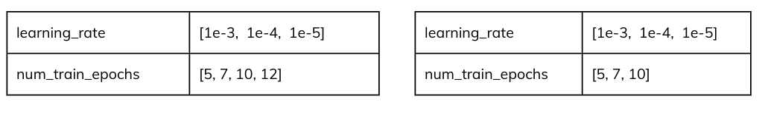

**Final Training Parameter**

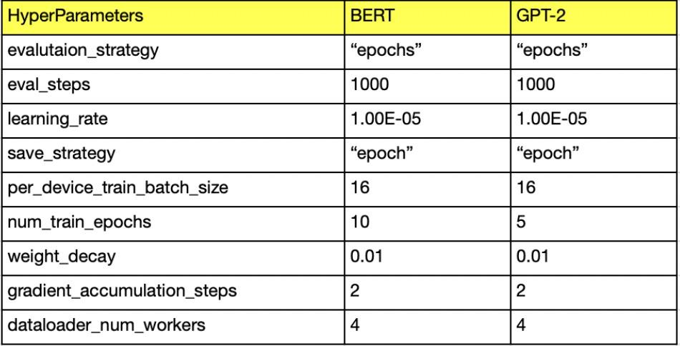

## 1.8 Result and Analysis

### 1.8.1 Results

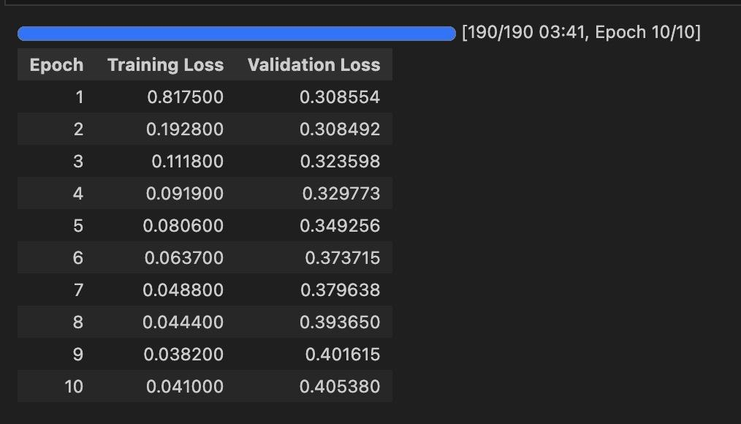

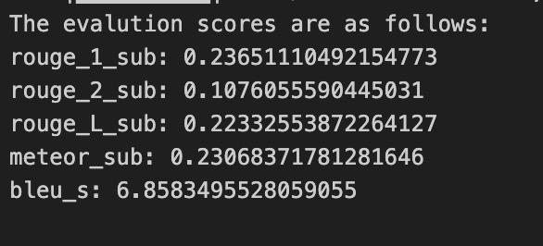

### 1.8.2 Deployment:

Upon completion of training and optimization procedures, the model was deployed, offering flexibility for deployment either locally or on cloud-based infrastructure. We employed Gradio and Streamlit approaches for deployment using free resources from google colab and hugging face.

**Gradio** is a popular tool for building web-based interfaces for machine learning models. In this deployment, the fine-tuned BERT model is hosted in a Google Colab notebook, and the inferencing is done directly within the notebook environment. Here's how it works:

**Prerequisites:**

* **Google Colab**: Ensure that you have access to a Google Colab environment with sufficient resources (preferably GPU/TPU) to perform model inferencing efficiently.

**Gradio Library**: Install the Gradio library within your Colab notebook.

* **Model Hosting**: You will load your fine-tuned BERT model from its saved location (either locally or from Hugging Face) in the Colab notebook.
* **Colab GPU**: Optional, but highly recommended to use GPU resources for faster inferencing.

**Internal Working:**

1. **Colab as the Backend**: Your fine-tuned model will reside and perform inference directly in the Colab notebook.
2. **Gradio Interface**: Gradio creates a user-friendly interface in the notebook, allowing users to input email content, which is sent to the BERT model for generating a subject.
3. **Inferencing on Colab**: Once the input is provided, the BERT model processes the email body and generates a subject. This happens within Colab's environment, utilizing its resources (CPU/GPU).
4. **Exposing via Gradio**: The Gradio app is served locally, but can be accessed by generating a shareable URL (which is provided by Gradio).

**Steps to Deploy:**

1. Load the fine-tuned BERT model in Colab.
2. Set up the Gradio interface to capture email input and display the generated subject.
3. Start the Gradio app, and Colab will generate a link to access it remotely.

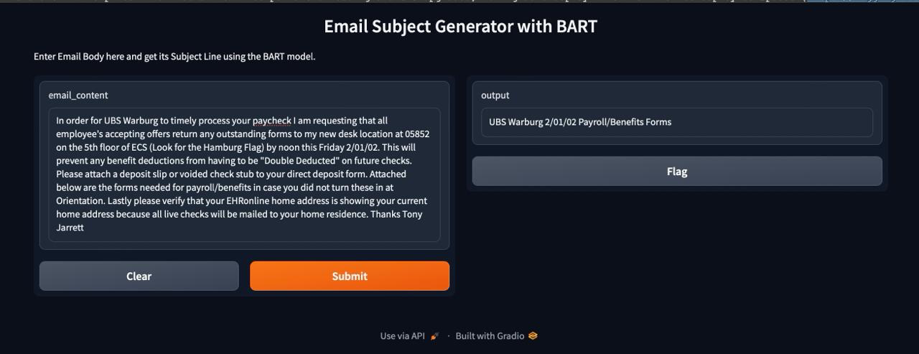

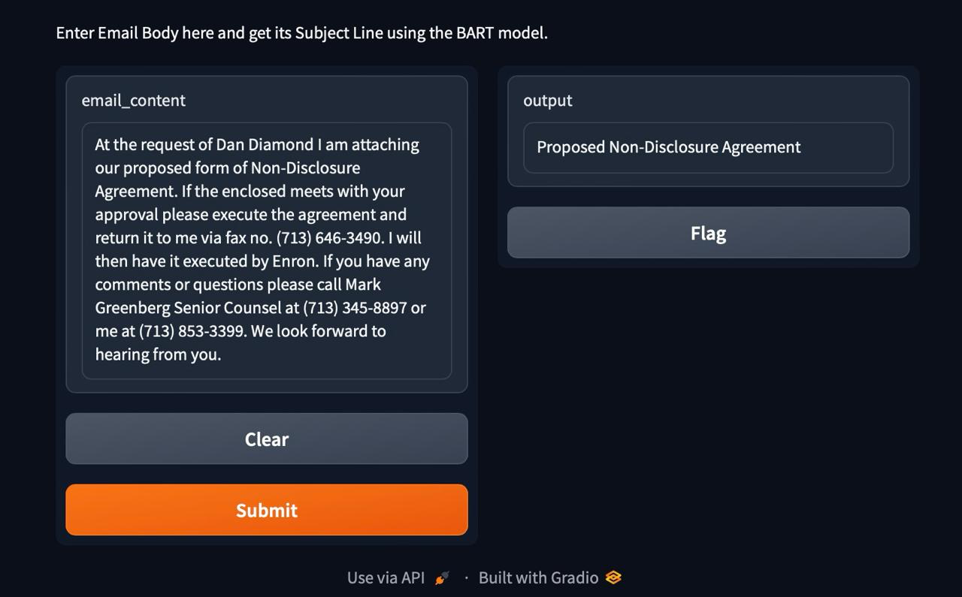

**Streamlit** is a powerful and easy-to-use Python framework for creating interactive web applications specifically for data science and machine learning projects. We’ve deployed using Streamlit cloud and it fetches the model from hugging face by creating an environment on the go.

**How Streamlit Works**

* Github Repository: Ensure that you’ve created a repository for your project
* Create a requirements.txt file in the github repository which has torch transformers and streamlit dependencies that needs to be installed when the model is being deployed.
* Create an app.py file for your project and that enables you to pull the model from HuggingFace and run it on streamlit environment.
* As soon you deploy the application, a web URL will be created for you that can be accessible anywhere.
* The inferencing of the model will be done your local machine, rather than the GPUs being available on Google Colab.

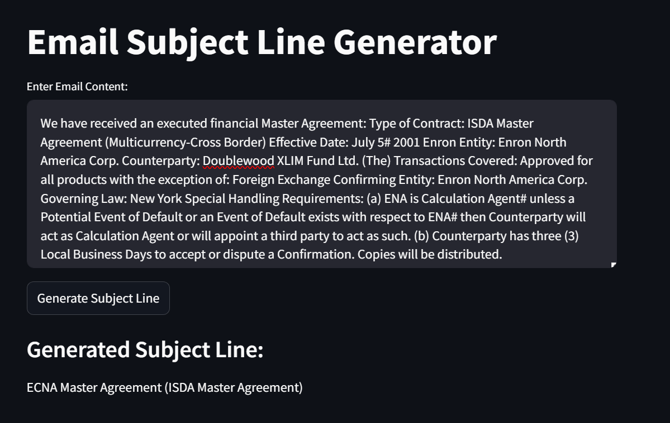

## 1.9 FUTURE SCOPE

**Multilingual Support:** One promising avenue for future exploration involves incorporating multilingual support into the task, offering significant advantages for global email communication. There is considerable potential in developing models capable of generating subject lines in diverse languages, presenting a crucial area for further development and research.

**Fine-Tuning for Specific Domains:** A promising direction for future endeavors lies in fine-tuning models tailored to specific domains, such as healthcare or finance. This customization has the potential to enhance the effectiveness of subject line generation, particularly within professional contexts and industries..

**Evaluation Metrics:** A significant potential avenue for future advancement involves the development of more sophisticated and domain-specific evaluation metrics to gauge subject line quality. Such metrics could greatly enhance the assessment and refinement of models, paving the way for more effective improvements in the field.

**Open-domain and Multi-turn Email Conversations:** An intriguing and challenging prospect for future research lies in expanding the task to encompass generating subject lines for open-domain emails or multi-turn email conversations. These areas offer exciting opportunities for exploration, presenting new challenges and avenues for innovation in the field.

## 1.10 Real World Application

Below, we outline several fundamental uses of an email subject line generation system, described in straightforward terms:

**Email Marketing Campaigns:** A significant practical application of this system is in email marketing campaigns. It assists businesses in crafting captivating and enticing subject lines for their marketing emails, thereby boosting the likelihood of customer engagement and interaction.

**Personal Email Efficiency:** In personal email management, this system streamlines efficiency by proposing pertinent subject lines, effectively saving time and enhancing communication fluidity and organization for individuals.

**Enhanced Communication:** The system enhances communication efficacy by proficiently summarizing email content, ensuring recipients swiftly grasp the message's intent, thereby optimizing overall email communication

**Language Translation:** In language translation, the system aids in crafting subject lines across various languages, facilitating international communication and broadening reach to a global audience.

**Spam Avoidance:** One practical application of this system is in spam avoidance. By generating subject lines that comply with email regulations, it assists in preventing emails from being flagged as spam, thus ensuring their delivery to the recipient's inbox.

## 

## 1.11 CONCLUSION

* In summary, refining a GPT model for the purpose of crafting succinct email subject lines directly from email bodies represents a formidable yet immensely worthwhile undertaking. It meets a pivotal requirement in digital communication by automating the generation of captivating and contextually pertinent subject lines. This not only streamlines processes but also amplifies the efficacy of email marketing and communication efforts. Furthermore, this endeavor presents avenues for innovation within Natural Language Processing (NLP), fostering the exploration of novel solutions, evaluation metrics, and user-centric enhancements. Ultimately, the successful execution of this task holds the potential to significantly enhance email communication experiences, offering tangible benefits to both senders and recipients in the contemporary digital landscape..

# 2. AI Question Answer Generation

## 2.1 Abstract

The "AI Question Answer Generation" project endeavors to tackle the significant challenge of automating the generation of accurate and coherent answers to questions posed in natural language. Its inception is rooted in the exponential proliferation of textual data and the escalating need for efficient information retrieval and comprehension. Amidst the rapid advancements in Artificial Intelligence and Natural Language Processing, the capability to leverage AI models for question answering has become indispensable across various sectors, spanning customer support, education, healthcare, and beyond. This project embarks on a mission to harness the potential of advanced AI models, particularly variants of the Generative Pre-trained Transformer (GPT), to develop a system proficient in deciphering the complexities of human language and furnishing informative responses to diverse queries. Leveraging a combination of fine-tuning techniques and the creation of domain-specific datasets, the project seeks to bridge the gap between generalized AI models and domain-specific expertise, providing a versatile tool for augmenting information accessibility and knowledge dissemination. Ultimately, the project aspires to revolutionize our interaction with extensive textual data repositories, envisioning AI-driven question answering as an integral component of our digital landscape.

## 2.2 Introduction

The project endeavors to develop an intelligent learning system capable of extracting knowledge from a provided text file. This system, armed with acquired knowledge, endeavors to respond to user inquiries effectively. Question Answering (QA) systems, designed to seek answers to open-domain questions within documents, serve as the project's focus. The primary objective of such systems is to foster research into mechanisms that furnish direct answers, aligning with the preference of numerous users, and to extend the advantages of large-scale evaluation to the QA task. Ultimately, the project's utility extends to diverse applications, including the online assessment of Frequently Asked Questions (FAQs) across various domains and interactive online lectures.

Our AI Question Answer Generation project is driven by the aspiration to enhance accessibility to information and enrich learning experiences. We've all encountered the exasperation of sifting through numerous web pages or documents in search of answers. This endeavor seeks to revolutionize that experience by developing intelligent computer programs capable of comprehending our queries and delivering precise, trustworthy responses in everyday language. Whether you're a student aiming to study efficiently, a professional in need of rapid insights, or simply an inquisitive individual, our aim is to make knowledge readily available at your fingertips, making learning and problem-solving a breeze in our information-rich world.

## 2.3 Problem Statement

The objective of this task revolves around constructing a question-answering system tailored to the domain of Artificial Intelligence and Machine Learning (AIML). With a provided set of questions pertaining to the AIML course and their corresponding answers, the aim is to develop a system capable of receiving a question as input and producing a precise and contextually pertinent textual response. The generated responses should demonstrate proficiency in AIML subjects outlined in the course material and should seamlessly align with the given questions.

## 2.4 Literature Study

Below is a literature review specifically dedicated to the task of "AI Question Answer Generation":

"Reviewing Question Generation: Methods and Applications" (2019): This thorough review examines diverse methods and applications of question generation within the realm of Natural Language Processing (NLP). It delves into techniques for generating questions from text, summarization, and other associated tasks.

"Text Summarization with Pre Trained Encoders" authored by Thomas Wolf et al.: This paper presents the BERT model and explores its utility in text summarization tasks.

"Fine-Tuning Language Models for Text Classification" authored by Tom B. Brown et al.: This paper examines different strategies for fine-tuning language models to cater to specific tasks.

"BERT: Pre-training of Deep Bidirectional Transformers for Language Understanding" authored by Jacob Devlin et al. (2018): This groundbreaking paper presents the BERT (Bidirectional Encoder Representations from Transformers) model, which has significantly influenced natural language understanding tasks, such as question answering.

Additional Resources

1. Hugging Face Transformers Library (https://huggingface.co/transformers/): This library provides pre-trained models, including BERT, GPT-2, and many others, along with code and tutorials for fine-tuning them for various NLP tasks.
2. ArXiv (https://arxiv.org/): A repository of research papers on a wide range of topics, including NLP and machine learning. You can search for papers related to specific NLP tasks and models.

## **2. 5 Methodology**

Below is an in-depth elucidation of the methodology employed for the "AI Question Answer Generation" task, outlined with the following key points:

### 2.5.1 Data Retrieval:

For the AI question answering task, the dataset was collaboratively curated by all project teams. It comprised Excel files labeled as "dev," "test," and "train." Within each file, entries included "question" and its corresponding answer labeled as "answer".

The prompt structure consists of bos token '<Question> ' followed by the question, truncated to the first 1000 words, and new line characters' separating different sections and the “Answer“ line with actual answer and eos token “ \n<ANSWER_ENDED>\n” at the end.

## **2.6 Experimentation**

### 2.6.1 Installing Required Libraries:

In order to streamline the development and training of the question answering model, crucial libraries and packages were installed. These encompassed essential libraries such as Transformers, Evaluate, Torch, and NumPy, alongside packages utilized for computing evaluation metrics like ROUGE Score, SacreBLEU, Bert Score, and GPT2Tok.

### 2.6.2 Model Selection:

In the context of the AI question answering task, a GPT-2 variant was selected as the primary model for text generation. GPT-2 models have exhibited robust performance across a spectrum of Natural Language Processing (NLP) tasks, rendering them well-suited for endeavors such as question generation and answering.

1. **Loss Metric Computation for Training and Validation:**

Throughout the training phase, loss metrics were calculated to gauge the disparity between the model-generated questions and answers and the target annotations. Similar to the approach employed in the email subject line generation task, these metrics were evaluated during training and on the validation dataset after each training epoch to monitor the model's advancement. To compute both training and validation loss, a range of evaluation metrics were utilized, including "Bleu," "Rouge" (specifically "R1," "R2," "RL," and "RLSum"), and Bert Score (comprising "F1" and "F2").

**BERT Score** is an automatic evaluation metric used for testing the goodness of text generation systems. Unlike existing popular methods that compute token level syntactic similarity, BERT Score focuses on computing semantic similarity between tokens of reference and hypothesis.

BERT Score involves Precision and Recall which are fundamental metrics used to evaluate the performance of various Natural Language Processing (NLP) tasks, including text summarization and text generation.

**Precision**: within the framework of BERT Score assesses the model's accuracy in correctly recognizing and scoring the similarity between reference and generated sentences. A high precision value indicates that the model assigns high scores to sentences that genuinely resemble the reference sentences. It is computed by dividing the number of true positive matches (i.e., sentences correctly identified as similar) by the total number of sentences identified as similar by the model (true positives + false positives).

**Recall**: conversely, evaluates the model's capability to detect all pertinent similar sentences within the reference sentences. In the realm of BERT Score, a high recall value signifies that the model can apprehend a substantial portion of the relevant information from the reference sentences. This metric is computed by dividing the number of true positive matches (i.e., sentences correctly identified as similar) by the total number of sentences that are similar in the reference (true positives + false negatives).

### 2.6.3 Hyperparameter Optimization:

In Pursuit of improving model efficacy, a meticulous examination of hyperparameters was undertaken. This process entailed the systematic exploration of various model architectures, learning rates, and batch sizes. Through rigorous experimentation, the influence of these hyperparameters on loss metrics was meticulously observed and analyzed, aiming to refine the model's overall performance.

Below are the findings from some of the experiments conducted to facilitate hyperparameter optimization:-

**Final Training Parameter**

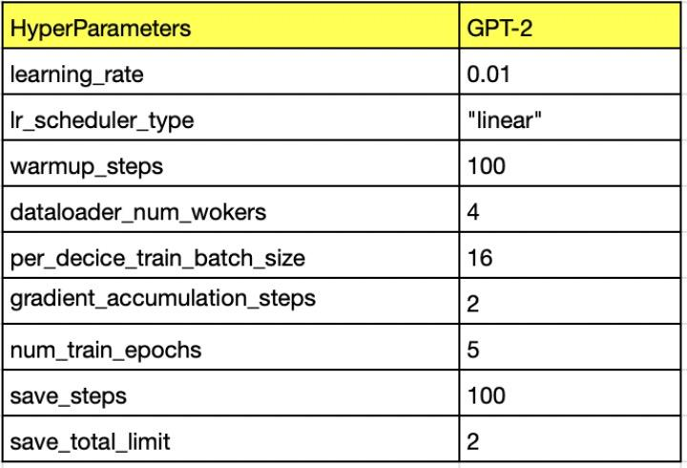

## **2.7 Result and Analysis**

### 2.7.1 Results

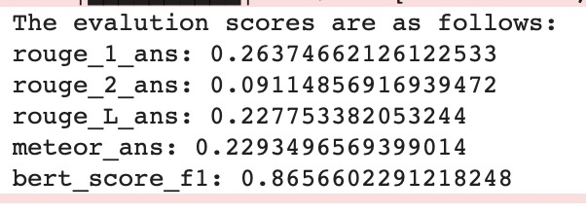

### 2.7.2 Deployment:

Following training and optimization, the model underwent deployment. This deployment process could occur either locally or on a cloud-based infrastructure.

We employed Gradio and Streamlit approaches for deployment using free resources from google colab and hugging face.

**Gradio** is a popular tool for building web-based interfaces for machine learning models. In this deployment, the fine-tuned GPT-2 model is hosted in a Google Colab notebook, and the inferencing is done directly within the notebook environment.

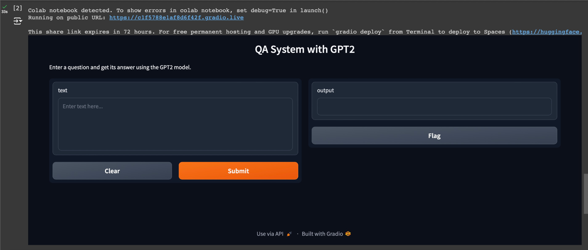

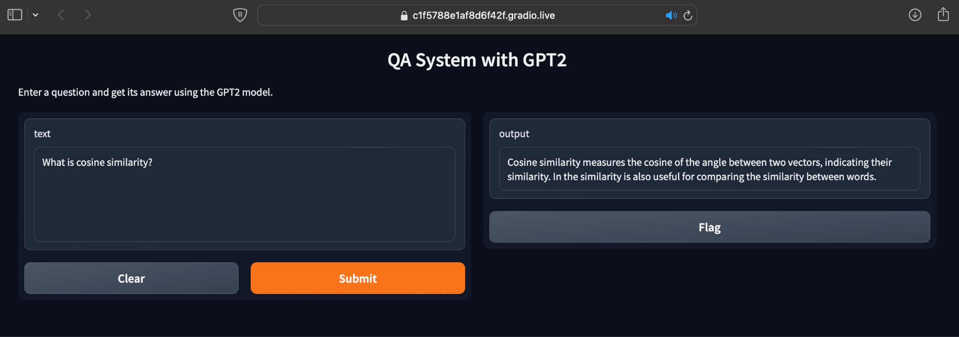

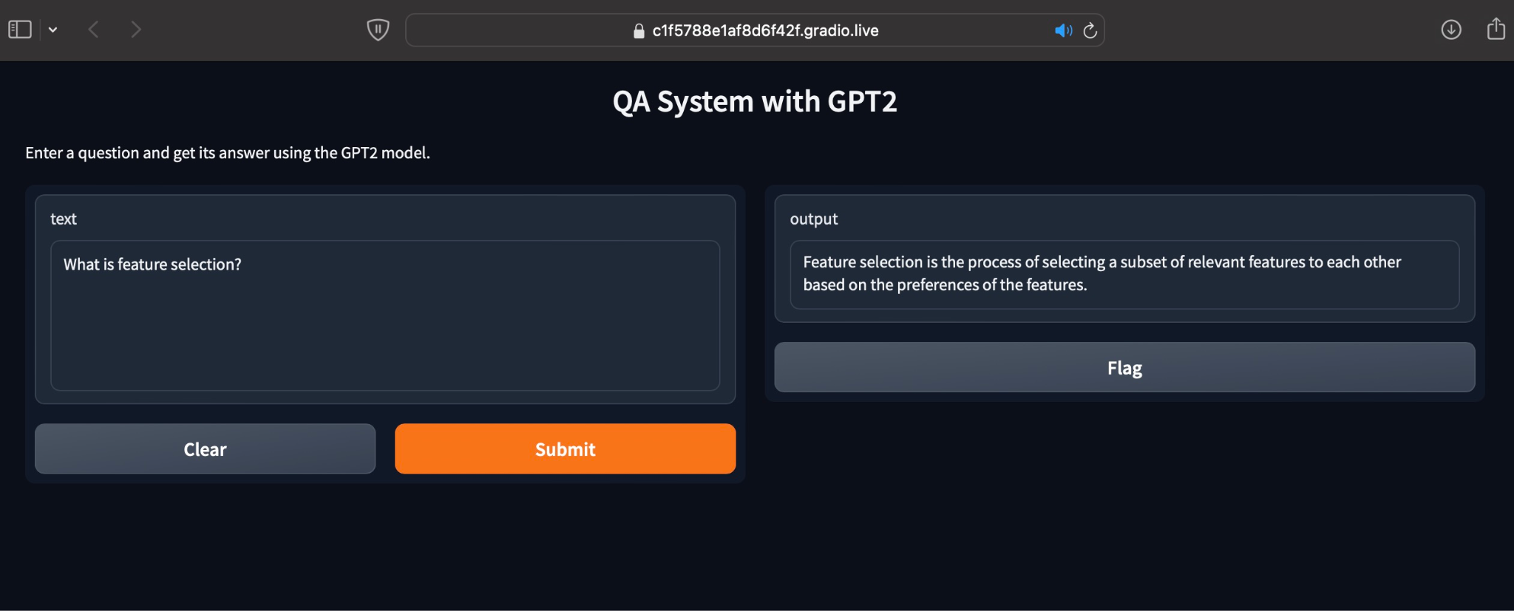

**Streamlit** is a powerful and easy-to-use Python framework for creating interactive web applications specifically for data science and machine learning projects. We’ve deployed using Streamlit cloud and it fetches the model from hugging face by creating an environment on the go.

How Streamlit Works

* Github Repository: Ensure that you’ve created a repository for your project
* Create a requirements.txt file in the github repository which has torch transformers and streamlit dependencies that needs to be installed when the model is being deployed.
* Create an app.py file for your project and that enables you to pull the model from HuggingFace and run it on streamlit environment.
* As soon you deploy the application, a web URL will be created for you that can be accessible anywhere.
* The inferencing of the model will be done your local machine, rather than the GPUs being available on Google Colab.

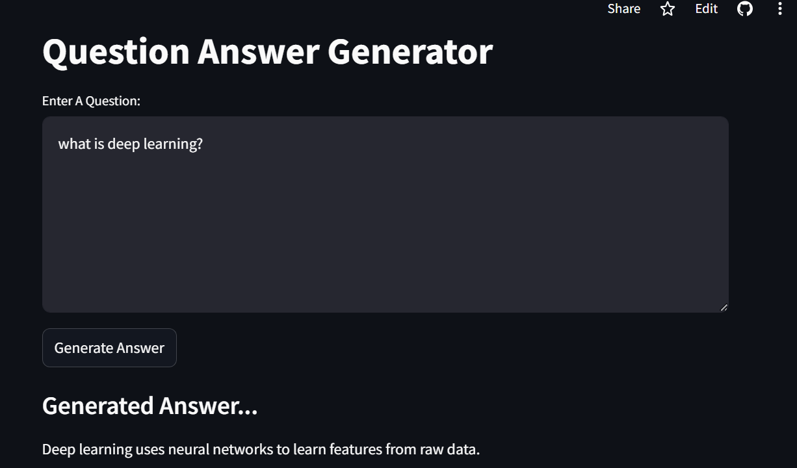

## **2. 8 FUTURE SCOPE**

**Domain Expansion**: Expanding the model to cater to a wider spectrum of STEM (Science, Technology, Engineering, and Mathematics) subjects, thus transforming it into a versatile resource for diverse educational fields.

**Real-time Conversational AI:** Incorporating QAG models into chatbots and virtual assistants to furnish instantaneous responses in natural language during interactions with users.

**Integration with Learning Management Systems:** Effortlessly incorporating the model into established educational platforms and Learning Management Systems (LMS) to elevate the learning journey for both students and educators.

**Virtual Teaching Assistants:** Creating AI-driven virtual teaching assistants capable of aiding instructors in addressing student queries and offering guidance on course administration.

**Multilingual and Global Reach:** Broadening the model's language capabilities and tailoring it to serve international audiences, thereby ensuring the accessibility of AIML education on a global scale.

## **2.9 Real World Application**

Below are several practical implementations of AI Question Answer Generation in real-world scenarios:

**Educational Content Creation:** AI question answer generation has the potential to automate the production of quiz questions and corresponding answers for educational resources. This technology empowers teachers and content creators to streamline the generation of assessments and study materials, thus saving valuable time.

**Customer Support Chatbots:** By integrating AI question answer generation, chatbots can deliver prompt and precise responses to customer queries. Capable of addressing frequently asked questions and resolving common issues, these AI-driven assistants optimize customer support operations, ensuring swift and accurate assistance.

**Legal Document Analysis:** Within the legal domain, AI can analyze legal documents and formulate questions and answers pertaining to particular cases, laws, or contracts. This capability streamlines legal research endeavors and facilitates the document review process, offering valuable assistance to legal professionals.

**Medical Diagnosis Support:** AI-powered question answering systems offer invaluable assistance to healthcare professionals by furnishing answers to medical inquiries and diagnostic questions. This technology aids doctors in making well-informed decisions and swiftly accessing pertinent medical information.

**Content Recommendations:** AI-generated questions and answers can be leveraged by content recommendation engines to tailor content suggestions for individual users. This application is especially pertinent in online learning platforms, news websites, and e-commerce platforms, where it serves to enrich user engagement and satisfaction.

## **2.10 CONCLUSION**

* In summary, the development of a domain-specific GPT variant, meticulously adjusted to furnish accurate responses to AIML-related inquiries, marks a noteworthy advancement in the realm of Artificial Intelligence and Machine Learning (AIML). This endeavor effectively tackles the distinctive hurdles associated with crafting an educational tool tailored to a specific domain. Moreover, it highlights AI's capacity to enhance educational journeys, transcending mere answer generation to cultivate a more profound comprehension of AIML concepts. This endeavor stimulates the exploration of innovative AI methodologies and evaluation criteria, thereby pushing the boundaries of question-answering systems.